
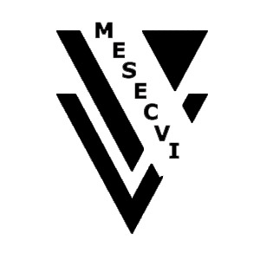
INTER-AMERICAN COMMISSION OF WOMEN

MEETING OF EXPERTS ON A FOLLOW-UP OEA/Ser.L/II.7.10
MECHANISM – Convention of Belém do Pará CIM/MESECVI/doc.2/04
July 20-21, 2004 30 June 2004
Washington, D.C. Original: Spanish

AGENDA
(Provisional)

Inaugural session
Remarks by the Chair of the Permanent Council
Remarks by the Assistant Secretary General, Ambassador Luigi Einaudi
input.doc

1. Election of the officers of the meeting: Chair, Vice Chair, and Rapporteur

- Presentation of the document: “Proposed Mechanism for Follow-up to the Inter-American Convention on the Prevention, Punishment, and Eradication of Violence Against Women, “Convention of Belém do Pará”

  - Presentation by the Executive Secretary of the CIM: Steps taken by the CIM to develop a mechanism for following up on implementation of the Convention of Belém do Pará.

  - Delegation of Mexico: Presentation of the working document and draft mechanism for follow-up of implementation of the Convention of Belém do Pará.

  - A representative of the Inter-American Commission on Human Rights: The advisability of having a follow-up mechanism.

  - Presentation by the Secretariat for Legal Affairs: A brief description of follow-up mechanisms for other inter-American conventions.

- Consideration of the draft follow-up mechanism for the Convention of Belém do Pará.

- Report of the rapporteur

- Approval of the Draft Mechanism for Follow-up to the Inter-American Convention on the Prevention, Punishment, and Eradication of Violence Against Women, “Convention of Belém do Pará”

