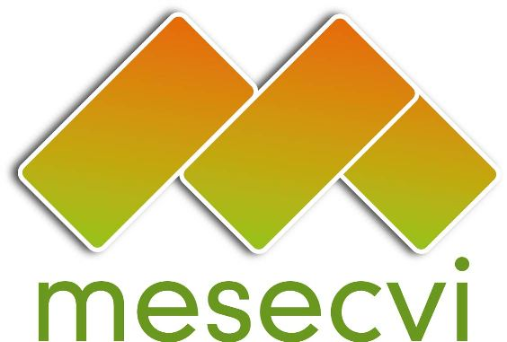
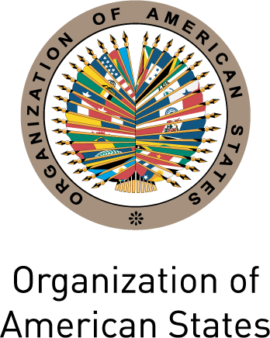

FOLLOW UP MECHANISM TO THE OEA/Ser.L/II.7.10
BELÉM DO PARÁ CONVENTION (MESECVI) MESECVI-V/doc.108/13 rev.6
FIFTH CONFERENCE OF STATES PARTY November 18th, 2013
November 18th – 19th, 2013 Original: Spanish
Washington D.C.

CALENDAR OF ACTIVITIES

(Draft)

Date: November 18th, 2013
Time: 8:30 to 16:00
Venue: Rubén Darío Room
General Services Building of the OAS
1899 F ST NW

Monday, November 18th

8:30 Registration of participants

9:00-9:30 Inauguration
- Remarks by the Secretary General of the OAS
- Remarks by the Chair of the Conference of States Party
Elizabeth Quiróa Cuellar, Executive Secretary of the Presidential Secretary of Women in Guatemala – SEPREM

9:30-9:45 Adoption of the Draft Agenda and Calendar of Activities (Item 2 of the Agenda)
Presentation of the Agenda Ambassador Rodrigo Vielmann, President of the preparatory meeting of the conference

9:45-10:15 Presentation of the Protocol on the Investigation of Femicide of the United Nations High Commissioner for Human Rights
Carmen Rosa Villa, Regional Representative for Central America, Office of the High Commissioner for Human Rights of the United Nations (OHCHR)

10:15-10:30 Election of the officers of the Conference: Chair, First and Second Vice Chairs, and Rapporteur (Item 1 of the Agenda)

10:30-13:00 Reflexion Process for strengthening the MESECVI (Item 3 of the Agenda)
- Luz Patricia Mejía, Technical Secretary of the MESECVI
- Launching the web page of the MESECVI
- Presentation of the Strategic Plan
- Invitation to a complete integration of the CEVI
- Presentation of the President of the CEVI about the strengthening of the CEVI.
Flor María Díaz Chalarca, President of the Committee of Experts of the MESECVI.
- Dialogue between the Competent National Authorities and the CEVI Experts
- General Guidelines for the functioning of the CEVI
- Participation of the Presidency of the Conference of States Parties in the CEVI meetings.
- Consideration of the procedure for the modification of the Rules of Procedure of the CEVI (in reference to the Tenth Meeting of the Committee of Experts)
- Promotion of the participation of the civil society and other actors in the activities of the MESECVI, according to the Article 10.2 of the Statute of the MESECVI.
- Creation of the Solidarity Subfund
- Constitution of a working group
- Conformation
- Term
- Objectives

Comments

13:00-14:30 Lunch

14:30-15:30 Continuation of the comments

15:30-14:30 Progress Indicators for measuring the Implementation of the Belém do Pará Convention Report (Item 4 of the Agenda)
Luz Patricia Mejía, Technical Secretary of the MESECV

16:00-18:00 Good Practices in Gender Justice (Item 5 of the Agenda)

Presentation of the initiative
Hilary Anderson, Principal Specialist of the Inter American Commission of Women (CIM)

Presentation of the Protocol on Judging from a Gender Perspective
Adriana Ortega Ortiz, Director of the Unit of Gender Equity of the National Supreme Court of Justice, México

Comments

Tuesday, November 19th

Date: November 19th, 2013
Time: 9:00 to 17:00
Venue: Simón Bolívar Room
Main Building of the OAS
1700 Constitution Avenue NW

9:00-10:00 Violence against Women: Advances and challenges in 20 years of the Belém do Pará Convention (Item 6 of the Agenda)

Contributions for the entry into force of the Convention on preventing and combating violence against women and domestic violence (Istanbul Convention)

Marja Ruotanen, Director of Justice and Human Dignity, Directorate General of Human Rights and Rule of Law, Council of Europe

Maria Cecilia Guerra, Vice Minister for Equal Opportunities, Italy

Guadalupe Romero, President of the Agency for Family Development (DIF) of the State of Hidalgo, Mexico

10:00-12:30 Ministerial dialogue on advances and challenges on the application of the Belém do Pará Convention. Regional experiences

12:30-13:00 Ceremony for the Accession of the Italian Republic to the Belém do Pará Convention
CIM03519E01

13:00 -14:00 Lunch

14:00 – 14:15 Definition of the date and offer to host the Sixth Conference of State Party (Item 7
of the Agenda)

14:15 – 14:30 Adoption of the Agreements of the Fifth Conference of States Party of the MESECVI (Item 8 of the Agenda)

14:30 – 15:15 Rapporteur’s Report of the Conference (Item 9 of the Agenda)

15:15 – 15:45 Other matters (Item 10 of the Agenda)

15:45 – 16:00 Closing remarks

19:00 – 20:30 Play: Wounded to Death
Salón de las Américas – Main Building (MNB) 17th Street and Constitution Ave., N.W., Washington, D.C. 20006, USA
Organized by the CIM and the Italian Agency MISMAONDA

20:30 Cocktail reception
Offered by the Ambassador Sebastiano Fulci, Permanent Observer of Italy to the Organization of American States

