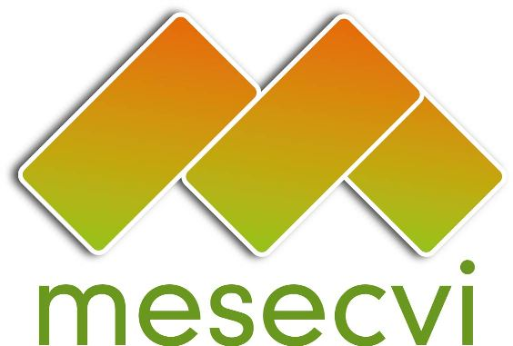
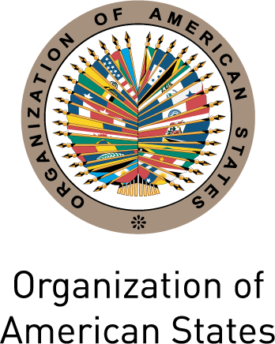

FOLLOW-UP MECHANISM OEA/Ser.L/II.7.10
CONVENTION OF BELÉM DO PARÁ (MESECVI) MESECVI/CEVI/doc.220/15
Twelfth Meeting of the Committee of Experts (CEVI) October 9th, 2015
October 13 th - 15 th 2015 Original: Spanish
Lima, Perú

Agenda
(Draft)

- Adoption of the Draft Agenda and Organization of Work
- Prevention of gender-based violence
- Challenges in the Implementation of the Recommendations of the Committee of Experts (CEVI) in Latin America and the Caribbean
- Presentation of the Report on the work of the President of the CEVI
- Presentation of the Report on the work of the Technical Secretariat of the MESECVI and the annual work plan 2016
- General Debate about the Implementation of the Second Follow-up Report of the Recommendations
- General Debate about the beginning of the Third Evaluation Round
- Adequation of the legal framework
- Presentation of the Project “political violence against women”
- Election of the authorities of the CEVI: President and Vice President
- Other matters
- Adoption of agreements

