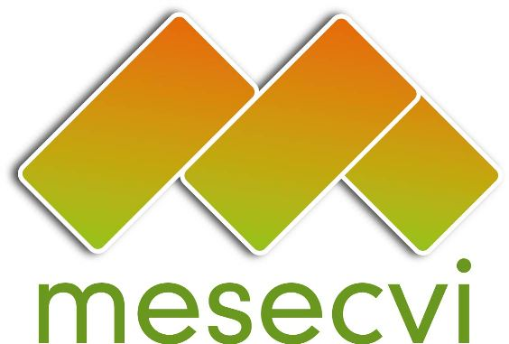
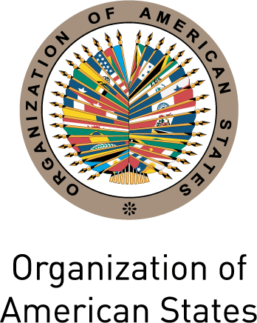

FOLLOW-UP MECHANISM OEA/Ser.L/II.7.10
CONVENTION OF BELÉM DO PARÁ (MESECVI) MESECVI/CEVI/doc.221/15
Twelfth Meeting of the Committee of Experts (CEVI) October 9th, 2015
October 13 th - 15 th 2015 Original: Spanish
Lima, Perú

ORGANIZATION OF WORK
(Draft)

October 13 th - 15 th 2015

Tuesday October 13 th 2015

Hall Múltiple, Carlos García Bedoya Building

Jirón Lampa 545 - Cercado de Lima, Lima, Peru

9:00 – 10:00 Opening Ceremony
- Marcela Patricia María Huaita Alegre, Minister for Women and Vulnerable Population, Peru
- Silvia Loli, Executive Director of Gender Violence, Ministry for Women and Vulnerable Population and Principal Expert of Peru
- Flor de María Díaz, President of the Committee of Experts of the MESECVI, Colombia
- Luz Patricia Mejía Guerrero, Technical Secretary of the MESECVI

10:00 – 10:15 Break/ official picture

10:15 – 12:00 Dialogue with civil society organizations (Article 27c of the Rules of Procedure of the Committee of Experts (CEVI)
- Representative of Flora Tristán
- Representative of PROMDSR-PROMSEX
- Representative of Casa de la Mujer
- Representative of DEMUS

Plenary debate

12:00 – 13:30 Lunch

13:30 – 13:45 Adoption of the Draft Agenda and Organization of Work

13:45 – 15:30 Prevention of gender-based violence
- Social and institutional tolerance of gender-based violence
Flor María Díaz Chalarca, President of the CEVI, Principal Expert of Colombia
- Education in stereotypes
Barbara Bailey, Principal Expert of Jamaica (tbc)
- New Masculinities
Leila Linhares, Principal Expert of Brasil

Debate

15:30 – 15:45 Break

16:00 – 17:30 Challenges in the Implementation of the Recommendations of the Committee of Experts (CEVI) in Latin America and the Caribbean
- Miselle O’Brien, , Expert of St. Kitts and Nevis
- Silvia Loli, Principal Expert of Peru

Debate

Wednesday October 14 th 2015

Hall Múltiple, Ministry of Foreign Relations

9:00 – 9:30 Presentation of the Report on the work of the President of the CEVI
Flor de María Díaz, President of the CEVI

9:30 – 10:00 Presentation of the Report on the work of the Technical Secretariat of the MESECVI and the annual work plan 2016
Luz Patricia Mejía Guerrero, Technical Secretary of the MESECVI
10:00 – 11:30 General Debate about the Implementation of the Second Follow-up Report of the Recommendations
- Divulgence and dissemination of the Follow-up Reports
- Thematic reports
- Sexual violence and adolescent pregnancy. Forced maternity
- Legislative progress in the protection of gender-based violence. Comprehensive laws

Debate

11:30 – 12:30 General Debate about the beginning of the Third Evaluation Round
- Approval of the methodology and determination of the subgroups of work
- Evaluation of the incorporation of:
- Access to Justice indicators in the region
- Prevention and education in stereotypes

Debate

12:30 – 14:00 Lunch

14:00 – 16:00 Adequation of the legal framework
- Quorum
- Virtual meetings
- Technical assistance visits
- Participation of the civil society organizations registered in the OAS
- Application procedure for issuance of letters and recommendations
- Amicus curiae

16:00 – 17:00 Presentation of the Project “Political violence against women”
Marta Martínez, Gender and Democracy Specialist of the Inter-American Commission of Women

Comments by the experts of the Working Group on “Political Violence against Women in the Convention of Belém do Pará”:
- Susana Chiarotti
- Diana González Perrett
- María del Carmen Alanís

Plenary debate and adoption of the recommendations

17:30 – 17:15 Election of the authorities of the CEVI: President and Vice President

17:15 – 17:30 Other matters

17:30 – 18:00 Adoption of agreements

18:00 Closing remarks
- Alejandra Mora Mora, President of the Conference of the States Parties, Costa Rica
- President of the CEVI

18:30 Reception of the Committee of Experts of the Follow-Up Mechanism to the Belem do Para Convention - CEVI

Thursday, October 15th:

8:30 Registration of participants

Meeting Room:

9:00-09:30 Adoption of the Draft Agenda and Calendar of Activities of the Sixth Conference of States Party (Item 1 of the Agenda)

9:30 – 10:00 Election of the officers of the Conference: President, First and Second Vice President and Rapporteur (Item 2 of the Agenda)

Plenary Room:

10:00 – 11:30 Opening Session: Tenth Anniversary of the MESECVI

Intervention by the President of Peru, Ollanta Humala

- President of the CEP
- Alejandra Mora Mora, President of the CIM, Minister for the Status of the Women, Costa Rica
- President of the CEVI
- Carmen Moreno Toscano, Executive Secretary, Inter-American Commission of Women, CIM/OEA

11:30 – 12:00 Break/ Official photograph

12:00 – 17:30 DIALOGUE BETWEEN COMPETENT NATIONAL AUTHORITIES AND THE COMMITTEE OF EXPERTS OF THE MESECVI (Item 3 of the Agenda) about:

12:00 – 13:30 Panel 1: International responses to violence against women

Keynote Speech: Silvia Pimentel, Member of the United Nations Committee on the Elimination of Discrimination against Women (CEDAW)

- Bridget O’Loughlin, Executive Secretary of GREVIO / Committee of States Party to the Istanbul Convention
- Andrew Morrison, Head of the Gender and Diversity Division (GDI), Inter-American Development Bank (IDB)
- Luiza Carvalho, Regional Director of UN Women for the Americas and the Caribbean, UN Women (TBC)
- Pamela Villalobos, Senior Social Affairs Officer, Division for Gender Affairs, ECLAC

Moderator: Ana María Mendieta, Vice-Minister for Women and Vulnerable Populations, National Competent Authority, Peru.

Dialogue/Questions and answers session

13:30 – 14:30 Lunch

14:30 – 16:00 Panel 2: Latin-America and the Caribbean: Building Bridges for the implementation of the Convention of Belém do Pará

- Eleonora Menicucci, Minister of the Special Secretariat of Policies for Women, Competent National Authority, Brazil
- Miselle O’Brien, Expert of the CEVI, Saint Kitts and Nevis
- Susana Chiarotti, Expert of the CEVI, Argentina
- Francine Foster, Expert of the CEVI, Grenada
- María del Carmen Alanís, Expert of the CEVI, Mexico
- DEMUS representative

Moderator: President of the CEVI

Dialogue/Questions and answers session

16:00 – 17:30 Panel 3: A regional view of structural violence against women

- Strereotypes and access to justice
Diana González Perrett, Expert of the CEVI, Uruguay
- Social and institutional tolerance of violence against women
Martha Ordóñez Vera, National Competent Authority, Presidential Advisor for Gender Equity, Colombia
- Femicide/Feminicide
Ana Maria Mendieta, Vice Minister of Women and Vulnerable Populations and Competent National Authority of Peru

Moderator: Ana María Baiardi, National Competent Authority, Minister of Women, Paraguay

Dialogue/Questions and answers session

17:30 – 18:00 Political Violence and Harassment against women (Item 4 of the Agenda)
- Presentation: Alejandra Mora Mora, National Competent Authority, President of the CIM, Minister for the Status of the Women, Costa Rica
- Consideration and Adoption of the Declaration on Political Violence and/or Harassment against women

18:00 Cultural evening

