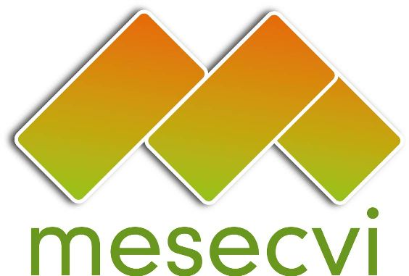
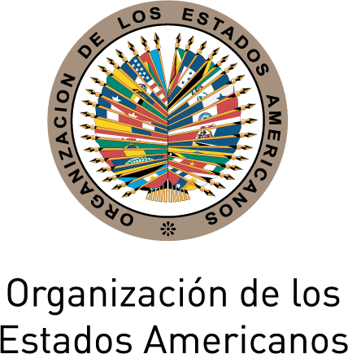

FOLLOW-UP MECHANISM TO THE OEA/Ser.L/II.7.10
BELÉM DO PARÁ CONVENTION (MESECVI) MESECVI/CEVI/doc.225/15.rev1
Twelfth Meeting of the Committee of Experts 14th October 2015
13-14 October 2015 Original: Spanish
Lima, Peru

AGREEMENTS OF THE TWELFTH MEETING OF THE COMMITTEE OF EXPERTS OF THE MECHANISM TO FOLLOW UP ON THE IMPLEMENTATION OF THE
INTER-AMERICAN CONVENTION ON THE PREVENTION, PUNISHMENT, AND ERADICATION OF VIOLENCE AGAINST WOMEN,
“BELÉM DO PARÁ CONVENTION” (CEVI)

The Committee of Experts of the Follow-Up Mechanism to the “Belém do Pará Convention,” assembled at the Twelfth Meeting, Sixth Conference of States Party to the MESECVI, from October 13-14, 2015, in the city of Lima, Peru:

AGREES TO:

- The election of the new authorities of the CEVI: Diana González Perrett, Expert of Uruguay, as the President; Miselle O’Brien, Expert of Saint Kitts and Nevis, as the First Vice-President; and Silvia Mesa Peluffo, Expert of Costa Rica, as the Second Vice-President;

- Adopt the “CEVI Work Plan 2015-2017,” document MESECVI/CEVI/doc.224/15 and begin the Third Multilateral Evaluation Round;

- Approve the document “Composition of the working subgroups for the Third Evaluation Round,” pursuant to Art. 3 e) of the Rules of Procedure of the Committee;

- Request that the Technical Secretariat include the indicators on education on stereotypes presented in document MESECVI/CEVI/doc.229/15 in the document Progress Indicators for Measuring the Implementation of the Belém do Pará Convention for the Member States;

- Ask the Technical Secretariat to circulate the document Progress Indicators for Measuring the Implementation of the Belém do Pará Convention to the Member States, together with the Practical Guide to Use of the System of Progress Indicators for Measuring the Implementation of the Belém do Pará Convention, in the period established in the Work Plan;

- Encourage the States Party to supply the information on the “Progress indicators for measuring the implementation of the Inter-American Convention on the Prevention, Punishment and Eradication of Violence Against Women – Belém do Pará Convention”, by the deadline established in the 2015-2017 Work Plan;

- Reaffirm the importance of the exchange of good practices among all of the States Party, promoting, in particular, synergies for the exchange of experiences between Latin America and the Caribbean;

- Take note of the dialogue held between the Committee and civil society, and further, within the framework of the Third Multilateral Evaluation Round, the application of the Belém do Pará Convention on the following issues: a) Prevention of and services for sexual violence, teenage pregnancy, and forced motherhood; b) Stereotype-free education; c) Access to justice; and e) Social and institutional tolerance of gender violence; f) political violence against women;

- Carry out thematic reports on specific issues of interest to the CEVI;
input.doc
- Carry out technical assistance visits to States, when requested;

- Approve the table of contents of the thematic report on teenage pregnancy and sexual and reproductive rights, including ethnic and rural approach, document MESECVI/CEVI/doc.222/15, and form a working group to prepare that report and issue the corresponding recommendations;

- Encourage the project “Enhancing the institutional capacity of the States and the political parties to respond to political harassment and/or violence against women;”

- Approve the adaptation of the legal framework of the Committee of Experts, taking into account the recommendations issued by the First Special Conference of States Party to the MESECVI, and ask the Technical Secretariat to publicize and distribute it;

- Approve the document “Guidelines to process the request for technical assistance and communications emanating from the CEVI”, document MESECVI/CEVI.doc.223?15, for addressing situations that could merit the formulation of specific recommendations for the implementation of the Convention;

- Remind the States Party who have not yet appointed their experts to name their Principal and Alternate Experts, and to assure the conditions and the economic resources for the effective accomplishment of their duties;

- Encourage the States Party to adopt comprehensive laws for preventing, punishing and eradicating of violence against women;

- Recommend as a strategy to disseminate the Second Follow-up Report on the Recommendations of the Committee of Experts of the MESECVI, to organize activities between the Experts, the National Authorities and the OAS Representatives in the States Party.

