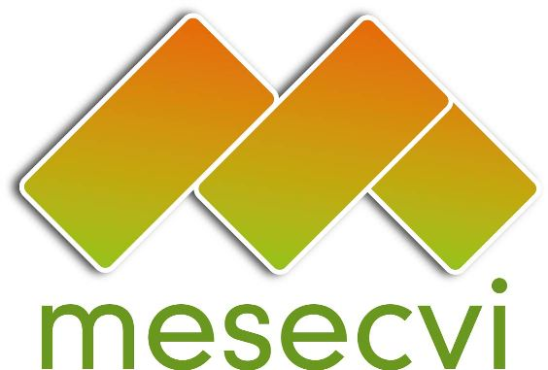
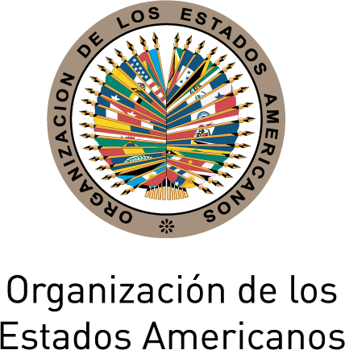

FOLLOW-UP MECHANISM TO THE OEA/Ser.L/II.7.10

BELÉM DO PARÁ CONVENTION (MESECVI) MESECVI-VI/doc.117/15.rev2

SIXTH CONFERENCE OF THE October 15th, 2015

STATES PARTIES TO THE Original: Spanish

CONVENTION OF BELÉM DO PARÁ

October 15 and 16, 2015

Lima, Peru

DECLARATION ON POLITICAL HARASSMENT AND
VIOLENCE AGAINST WOMEN

Lima, October 15, 2015

THE COMPETENT NATIONAL AUTHORITIES OF THE FOLLOW-UP MECHANISM TO THE INTER-AMERICAN CONVENTION ON THE PREVENTION, PUNISHMENT AND ERADICATION OF VIOLENCE AGAINST WOMEN, BELÉM DO PARÁ CONVENTION (MESECVI) OF THE ORGANIZATION OF AMERICAN STATES (OAS), meeting in the City of Lima, Peru on October 15, 2015 on the occasion of the Sixth Conference of the States Parties to the Convention of Belém do Pará;

CONSIDERING:

That the American Convention on Human Rights, the Inter-American Convention on the Granting of Political Rights to Women, the Convention on the Elimination of all Forms of Discrimination Against Women, the Additional Protocol to the American Convention on Human Rights in the area of Economic, Social, and Cultural Rights, “Protocol of San Salvador,” and the Inter-American Convention on the Prevention, Punishment, and Eradication of Violence Against Women, “Convention of Belém do Pará” comprise a corpus juris for the protection of the political rights of women;

That as the Convention of Belém do Pará establishes, violence against women shall be understood as any act or conduct, based on gender, which causes death or physical, sexual or psychological harm or suffering to women, whether in the public or the private sphere;

That the Convention of Belém do Pará establishes that the States Party condemn all forms of violence against women and the duty of States Parties to adopt, without delay and by all appropriate means, policies designed to protect these rights and to prevent, punish, and eradicate violence against women in public and private spheres;

That the Inter-American Democratic Charter establishes that “States shall promote the full and equal participation of women in the political structures of their countries as a fundamental element in the promotion and exercise of a democratic culture;”

That the Social Charter establishes that “the political participation of women, their full autonomy and independence, appreciation of their role in society and the economy, and education that promotes gender equality are essential for development and democracy in all countries”;

That the Declaration of the Inter-American Year of Women, “Women and Power: For a World of Equality” (CIM/DEC. 10 (XXXV-O/10), the Assembly of Delegates of the CIM declared its commitment to promote the measures necessary to prevent, punish, and eradicate political harassment of women; and

That the Declaration of Pachuca, “Strengthening Efforts to Prevent Violence Against Women,” (CIM/CD/doc.16/14 rev.3) of the CIM Executive Committee, recognized that “the different forms of violence against girls and women, are still impeding their individual development, damaging their rights and liberties, obstructing the full development of their capacities and autonomy, and limiting their public, economic, social and political participation in our societies”;

That CEDAW Committee General Recommendation No.23 recommends States Parties to take the appropriate measures to eliminate discrimination against women in the political and public life of the State, on an equal footing with men;

That the consensuses reached by the Regional Conferences on Women of Latin America and the Caribbean, as well as the Conference on Population and Development, contain references to violence against women and political harassment of women;

TAKING INTO ACCOUNT:

The “Law No. 243 against political harassment and violence against women” of the Plurinational State of Bolivia (2012), as well as the efforts and the progress made in terms of the legislation and other measures implemented in other countries of the region;

The First and Second Hemispheric Reports on the Implementation of the Convention of Belém do Pará;

The report on Women’s Citizenship in the Democracies of the Americas, published by the Inter-American Commission of Women;

RECOGNIZING:

The need to make progress on a definition on political violence and/or harassment against women, taking into account the debates on the subject in the international and regional levels;

That both political harassment and violence against women may include any action, conduct, or omission among others, based on their gender, individually or collectively, that has the purpose or result of undermining, annulling, impeding, or restricting their political rights, violating the rights of women to a life free of violence and to participate in political and public affairs on an equal footing with men;

That political violence and harassment against women prevent them from being recognized as political subjects and thus discourage many women from entering or continuing political careers;

That the tolerance of violence against women hides political violence and harassment, which impedes the formulation and application of policies to address the issue;

That the use of symbolic violence as an instrument of political discussion gravely affects women’s exercise of their political rights;

That political harassment and/or violence against women have become more visible due to the increased political participation of women, especially as political representatives, which in turn is the result of implementation of gender quotas and parity policies, measures that have been adopted by a large number of countries in the Americas;

That political violence and harassment against women can occur in any area of public and political life: in government institutions, in polling booths, in political parties, social organizations and in trade unions, and through the media, among others;

That political harassment and/or violence against women are of particular gravity when perpetrated by public authorities;

That it is the responsibility of the State, citizens, political parties, social and political organizations, and trade unions, to foster legal and cultural changes in order to guarantee the substantive equality of women and men in political spheres, according to the recommendations of the United Nations Committee for the Elimination of Discrimination Against Women and the commitments assumed through the Convention of Belém do Pará;

That the problem of political harassment and/or violence against women highlights that to achieve political parity in a democracy, it is not enough to adopt quotas or ensure electoral parity; instead, it requires a comprehensive approach that on the one hand, ensures equal access of women and men to all government institutions and political organizations and, on the other hand, ensures that the conditions for exercising that access are free of discrimination and violence against women at all levels and in all arenas of political life;

The efforts of women in politics in the Americas to foster public policies in terms of political harassment and/or violence against women;

DECLARE:

Promote the adoption, where appropriate, of regulations, programs and measures for the prevention, attention, protection, eradication of political violence and/or harassment against women, that allow the proper punishment and reparation of these acts, in the administrative, criminal, electoral norms spheres, taking into account the applicable international instruments;

Promote and disseminate research that takes into account the nature and specificities of political violence and/or harassment against women, as well as generating statistical data on the issue, aiming to count on precise and up to date information that allows the adoption of laws, programs and appropriate measures, including specialized attention for victims;

Encourage the inclusion in public policies for prevention, attention and punishment of political violence and/or harassment against women of approaches that promote changes in structural factors that affect violence against women and socio-cultural and symbolic standards as well as social and cultural stereotypes that perpetuate it, assigning sufficient resources, as appropriate, for their effective, prompt and timely application;

Promote that public policies which are designed on political harassment and/or violence against women, and facilitate substantive equality and strengthen women’s leadership and their presence in decision-making positions and their application at the national and subnational levels;

Promote that electoral institutions and other public entities, as applicable, incorporate the issue of political harassment and/or violence against women in the framework of their functions related to the organization of elections, the protection of political-electoral citizenship rights, and the development of civic education policies, as well as in their work with political parties;

Promote the participation of women in politics and, as appropriate, in their organizations throughout the process of designing, implementing, monitoring, and evaluating public policies on the subject of political harassment and/or violence against women;

Promote that political parties, political and social organizations and trade unions, create their own internal instruments and mechanisms to prevent, punish and eradicate political violence and/or harassment against women, and to conduct internal awareness-raising and training activities on this issue;

Promote the celebration of workshops to educate professionals in the media and social networks on the subject of discrimination against women in politics by the media and political harassment and/or violence, using a human rights-based approach;

Promote the celebration of awareness-raising campaigns on the problem of political harassment and/or violence against women for the general public;

Encourage the media, advertising companies and social networks to develop and/or include in codes of ethics the issue of discrimination against women in politics by the media and the political harassment and/or violence to which they are subjected, underscoring the need to present women in a fair, respectful, broad and varied manner, at all levels of hierarchy and responsibility, eliminating sexist stereotypes that disqualify or hide their leadership in all decision-making spaces.
input.doc

Nicaragua is committed to the respect, promotion and protection of women’s human rights and condemns all forms of violence against them; nonetheless, Nicaragua expresses its reservation regarding the present declaration, due to the fact that it addresses concepts that have not been defined yet and do not have consensus of all the Member States to the OAS, thus, a larger analysis and discussion on this, is required, prior to approving a Declaration that would be hasty.

